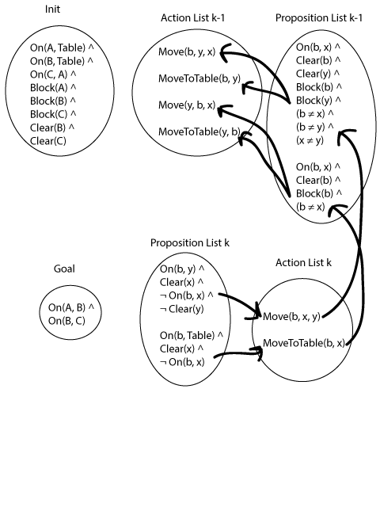

The precondition for Move is:

On(b, x) ∧ Clear(b) ∧ Clear(y) ∧ Block(b) ∧ Block(y) ∧ (b ≠ x) ∧ (b ≠ y) ∧ (x ≠ y)

The precondition for MoveToTable is:

On(b, x) ∧ Clear(b) ∧ Block(b) ∧ (b ≠ x)

The set of Move's preconditions that are not MoveToTable's preconditions is:

Clear(y) ∧ Block(y) ∧ (b ≠ y) ∧ (x ≠ y)

If this complement is false, then MoveToTable must be performed instead. Otherwise, Move can be performed.

¬(Clear(y) ∧ Block(y) ∧ (b ≠ y) ∧ (x ≠ y)) → MoveToTable(b, x)

(Clear(y) ∧ Block(y) ∧ (b ≠ y) ∧ (x ≠ y)) ∨ MoveToTable(b, x)

Move is then added to the left set of conditions, which satisfy it.

(Move(b, x, y) ∧ Clear(y) ∧ Block(y) ∧ (b ≠ y) ∧ (x ≠ y)) ∨ MoveToTable(b, x)

Adding back MoveToTable's preconditions, we get the final formula.

∃b∃x∃y (On(b, x) ∧ Clear(b) ∧ Block(b) ∧ (b ≠ x)) ∧ ((Move(b, x, y) ∧ Clear(y) ∧ Block(y) ∧ (b ≠ y) ∧ (x ≠ y)) ∨ MoveToTable(b, x))

The answer, as shown in the book, is [MoveToTable(C, A), Move(B, Table, C), Move(A, Table, B)].

